
EUROMECH Colloquium 662
Physics-enhanced machine learning and data-driven nonlinear dynamics
28 - 30 April 2026, Como, Italy

Title of the Abstract (Max Two Lines)
A. Author¹, B. Author²
¹ Affiliation, Country
Corresponding author: A. Author (email@domain)

Keywords: Please provide 3–5 keywords relevant to your contribution.
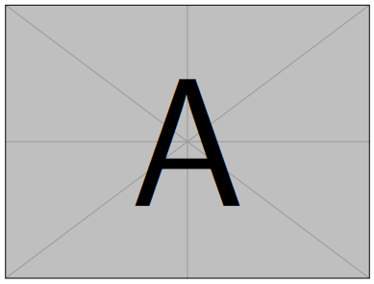
Write your abstract here. Keep the total length to one page including any figure and references. Example inline citation [1].
Figure 1: Example of figure (optional).
Page limit: 1 (including any figure and references).

References
[1] Title. Journal, pages xx–xx, year.

